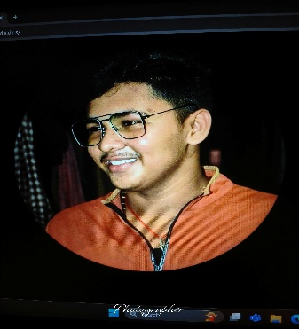 RESUME

DIBYA SHREE DIBYA RANJAN SAHOO

+91 98617 91209

E-mail Id: [sdibyashreedibyaranjan@gmail.com](mailto:sdibyashreedibyaranjan@gmail.com)

* Education
* [2021-2022 COUNCIL FOR THE HIGH SCHOOL CERTIFICATE EXAMINATION (10th) FROM SSVM, GONDIA,

GONDIA PATANA, DHENKANAL WITH AN PERCENTAGE OF 85% FROM [2021-2022

* MEMORANDUM OF MARKS HIGHER SECONDARY EXAMINATION (12th) FROM SANDA HIGHER SECONDARY

SCHOOL, SANDA, DHENKANAL WITH AN PERCENTAGE OF 52% FROM [2022-2024]

* THIS TIME I AM STUDING BSc.Computer Science IN LAKSHYA INSTITUTE OF TECHNOLOGY (LIT) ,ACHRYA

VIHAR, BHUBANESWAR

* Languages
* ODIA, HINDI, ENGLISH
* Skill
* BASIC C, BASIC HTML
* EXTRA ACTIVITY & HUBBY
* Sports – Badminton, Chess, Football, Kabaddi, Hocky, Carrom
* Travelling new places & Bike riding, Cycling
* PERSONAL DETAILS

FATHER NAME – NIRMAL CHANDRA SAHOO NATIONALITY-INDIAN

MOTHER’S NAME – MAMINA SAHOO RELIGION - HINDU

DOB – 18TH APRIL,2007

SEX – MALE

MARATIAL STATUS - UNMARRIED